**TUTORIAL NO: 2**

**Aim:-**

To implement calculator program using multithreaded server. Each user will be served by different thread, at the end of the calculations server will respond with all the calculations done by the specific user.

**Theory:-**

In computer software multithreading is the ability of central processing unit (CPU) or a single core in a multi-core system to execute multiple processes or threads concurrently, appropriately supported by the operating system. This approach differs from multiprocessing, as with multithreading the processes and threads share the resources of a single or multiple cores: the computing units, the caches etc.

Multithreading in Java:-

Multithreading is a Java feature that allows concurrent execution of two or more parts of a program for maximum utilization of CPU. Each part of such program is called a thread. So, threads are light-weight processes within a process.  
Threads can be created by using two mechanisms:  
1. Extending the Thread class  
2. Implementing the Runnable Interface

**Thread creation by extending the Thread class:-**  
We create a class that extends the **java.lang.Thread** class. This class overrides the run() method available in the Thread class. A thread begins its life inside run() method. We create an object of our new class and call start() method to start the execution of a thread, start() invokes the run() method on the Thread object.

If we extend the Thread class, our class cannot extend any other class because Java doesn’t support multiple inheritance.

We can achieve basic functionality of a thread by extending Thread class because it provides some inbuilt methods like yield() , interrupt() etc.

**Class Diagram:-**

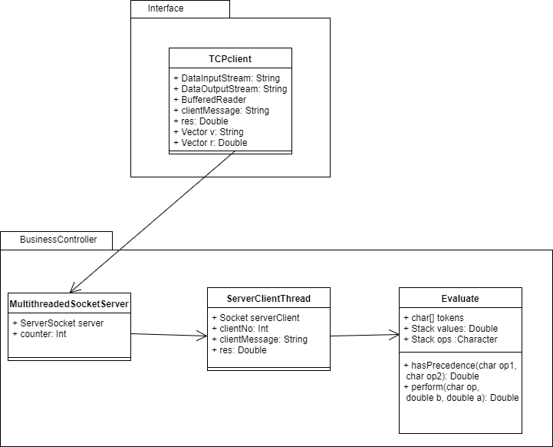

**Conclusion:-**

Class Evaluate contains all the methods required for calculator operations. On the interface side we have class TCPclient which connects to the MultithreadedSocketServer class. Every time a new client connects a new thread of class ServerClientThread is created. Thus we have implemented the calculator using multithreading concepts in Java.